The Upper Llano River Watershed Land Use/ Land Cover Project

Introduction

The objective of this project was to create a Land Use/Land Cover (LULC) dataset for the Upper Llano River Watershed (ULRW) in south-central Texas. The proactive development of a Watershed Protection Plan (WPP) for the North Llano River Watershed will help assist the South Llano River Alliance (SLWA) with their protection and conservation goals. This region influences many ecosystems inside and outside of the watershed, and the LULC map along with other GIS data will assist stakeholders and managers in making informed decisions. The LULC map was created through the use of National Agriculure Imagery Program (NAIP) images and a large amount of ancillary data along with the programs ArcGIS 9.3, ArcGIS 10, and Definiens Developer 7.0.

Study Area

The ULWR is comprised of two watersheds; the North Llano and South Llano. The watershed is found in south-central Texas in the Hill Country region. This region has karst geology and is west of the Balcones fault line. Mesquite (Prosopis glandulosa), Ashe Juniper (Juniperus ashei), and other brush species dominate the ULWR landscape. The watershed is located within six counties: Menard, Sutton, Kimble, Kerr, Real, and Edwards. The North Llano and South Llano River are the main rivers in the watershed, and they join at the eastern edge of the watershed in Junction, Texas. The ULWR is 4795 square kilometers with the North Llano being 2379 square kilometers and the South Llano 2416 square kilometers.

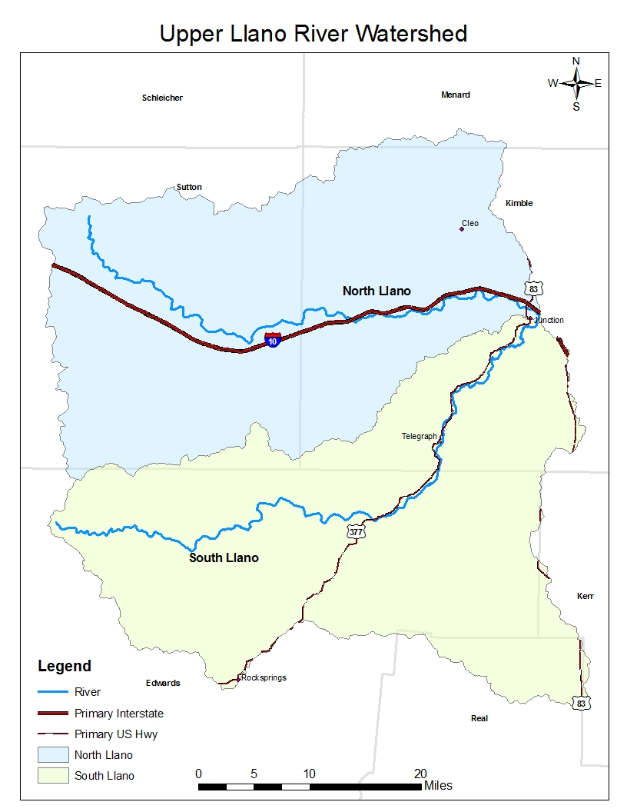
Map 1

NAIP 2010 Imagery Classification Process

In order to create a LULC map, a vast amount of data needed to be gathered. The following sections describe the data required and methods used to accomplish the task.

Data

National Agriculture Imagery Program (NAIP) Digital Ortho Imagery: NAIP Ortho photos are collected and compiled each year by the U.S. Department of Agriculture (USDA) Farm Service Agency (FSA) during a portion of the agricultural growing season at a one or two meter resolution. The 2010 images for Texas were provided in county mosaics at a spatial resolution of one meter.

Watershed Boundary Dateset Hydrological Unit Code 12-digit (WBD_HUC12): The WBD is provided by the U.S. Geological Survey (USGS) to delineate watershed boundaries using drainage systems and hydrological principles (USGS). This dataset displayed the study area and was used for clipping data to the study area.

National Land Cover Dataset: The NLCD 2001 was created by the USGS and was developed using a decision-tree classification approach for multi-temporal Landsat imagery and several ancillary datasets. The category of urban land was extracted from the dataset using the ArcGIS Spatial Analyst extension to compare and compliment the NAIP classification. The NLCD 2001 has a 30 meter resolution.

Crop Data Layer: The CDL 2010 was compiled by the USDA National Agriculural Statistics Service (NASS) and was used in the classification process to gather in depth cropland points in the watershed. A CDL is a small unit of land that has a permanent, contiguous boundary, with a common land use and owner, and a common producer in agricultural land associated with USDA farm programs. CDL boundaries are delineated from relatively permanent features such as fence lines, roads, and/or waterways. The CDL has a 30 meter resolution.

National Hydrography Dataset NHD: NHD is a database that interconnects and uniquely identifies segments or reaches that make up the nation’s surface water drainage system (USGS). The NHD assisted with the classification of Riparian zones.

Strategic Mapping Program (Stratmap): The Stratmap produces state-wide digital geographic data layers that establish a common base map for the state of Texas (TNRIS). Roads from the stratmap were used in the post-classification process for identifying classes.

Ground Truth Data: Samples for each LULC class within the study were gathered during May 2012 using a GeoTrimble Explorer 3 unit. The primary focus of the field collection process was to collect ground control points across the entire area, particularly in classes which were difficult to distinguish. Where access was limited, sample points were offset from the road with comments on each GPS point distinguishing where the point should be placed.

Programs

Definiens Developer 7.0: Definiens Developer 7.0 uses an object-based image analysis. Segmentation of images is accomplished through the application of rules and algorthims provided by the program. Definiens Developer 7.0 created the original classification of the ULRW.

ArcGIS 9.3 and 10: ArcGIS is used to analyze, process, edit, and create data through shapefiles, rasters, and other types of datasets. This program was used to prepare the data for further processing, and it was used for post-processing of the classified watershed.

ERDAS IMAGINE 2010: New information can be created through advanced remote sensing analysis and spatial modeling with Erdas Imagine. This program was used to create subsets of the NAIP images, so data would not be too large to process in Definiens Developer 7.0.

ENVI 4.7: ENVI 4.7 is a remote sensing program that analyzes and classifies rasters using Supervised or Unsupervised techniques. ENVI was used to create the Normalized Difference Vegetation Index band for the NAIP 2010 images.

Python 2.6.5: Python is an object-oriented programming language and is used in conjunction with many other programs. Python was used with ArcGIS to automate processes and reduce time.

LULC Class Definitions

- Urban – Areas characterized by a high percentage (30 percent or greater) of constructed materials (e.g. asphalt, concrete, buildings, etc).

- Open Water - Areas of open water with less than 25% cover of vegetation or soil.

- Barren Land - (Rock/Sand/Clay) - Barren areas of bedrock, desert pavement, scarps, talus, slides, volcanic material, glacial debris, sand dunes, strip mines, gravel pits and other accumulations of earthen material. Generally, vegetation accounts for less than 15% of total cover and includes transitional areas.

- Near Riparian Forested Land – Areas dominated by trees generally greater than 5 meters tall, and greater than 50% of total vegetation cover. These areas are found following in near proximity (within 30-60 m) to streams, creeks and/or rivers.

- Rangeland – Areas of unmanaged shrubs covering 14% or less of the area with unmanaged grasses covering the rest of the area.

- Cultivated Crops - Areas used for the production of annual crops, such as corn, soybeans, vegetables, hay, and cotton, and also perennial woody crops such as orchards and vineyards. Crop vegetation accounts for greater than 20% of total vegetation. This class also includes all land being actively tilled.

- Brush Low Density - Areas dominated by woody canopy cover, including ashe juniper, mesquite, live oak and other brush species and comprise 15-30% of total vegetation cover. Where possible, species level analysis will be performed.

- Brush Medium Density - Areas dominated by woody canopy cover, including ashe juniper, mesquite, live oak and other brush species and comprise 30-60% of total vegetation cover. Where possible, species level analysis will be performed.

- Brush High Density - Areas dominated by woody canopy cover, including ashe juniper, mesquite, live oak and other brush species and comprise greater than 60% of total vegetation cover. Where possible, species level analysis will be performed.

Preparation of Data

ArcGIS 9.3, ERDAS Imagine 2010, Definens Developer 7.0, and ENVI 4.7 were used for the pre-processing of data for the ULRW. First, all the data described above was projected to North American Datum (NAD) 1983 Universal Transverse Mercator (UTM) coordinate zone 14 North. The North and South Llano Watershed were exported from the WBD_HUC12 and merged together to identify the ULRW. A 1 mile buffer was placed around the ULRW to ensure the whole watershed would be included. Then, the NAIP 2010 images for the counties Real, Sutton, Kerr, Menard, Kimble, and Edwards were gathered and clipped to the buffered study area. All the data listed above was clipped to the study area as well. After the 1 meter NAIP images are clipped, ERDAS IMAGINE 2010 is used to create 2 gigabyte tiles for the images. The images need to be tiled in order for Definiens Developer to process the images. Each clipped county image was comprised of approximately 4 tiles. After the images were tiled, a NDVI band was created for each tile in ENVI 4.7. The NDVI band assists in differentiating vegetation from non-vegetation in the classification process. Now that the NAIP images are tiled and a NDVI band is added, the images are loaded into Definiens Developer 7.0. Since the NDVI band is a floating point, the tiled image size increased dramatically from its original 2 gigabyte size. Definiens Developer 7.0 is used to tile the images even further and creates 113 total images at 10000 x 10000 pixels to comprise the ULRW.

Classification

Now that the data is NAIP 2010 images are prepared, they can be classified in Definiens Developer 7.0. First, the NDVI band is used to create an initial classification between vegetation and non-vegetation in the image. Any cell with an NDVI greater than or equal to 0.15 is vegetation, and any cell less than 0.15 is considered non-vegetation. Now, the images can be segmented within vegetation and non-vegetation classes based on parameters given by the user. The main goal was to get a segmentation that identifies only brush and excludes objects in the vicinity. This will be very helpful for brush density calculations. After the proper segmentation is achieved, samples can be collected for the classes. At least 5 samples from each class was collected per 10000 X 10000 pixel tile, and this allowed at least 25 samples per class to be collected per larger tiles created in ERDAS IMAGINE 2010. The classes below were used for classification in Definiens Developer 7.0, and other classes will be added during the post-classification process. Some classes like Live Pasture and Rangeland Grass are the same class, but two different classes were needed because of the difference in their cell values. Rangeland Green was brush but its reflectance was green.

Classes:

1) Water
2) Barren
3) Developed
4) Roads
5) Live Pasture
6) Rangeland Grass
7) Rangeland Other
8) Rangeland Juniper
9) Rangeland Green
10) Shadow

After the images are classified, the segments (objects) are exported as shapefiles with their class name in the attribute table, and the classification raster is exported as well.

Collecting Ground Truth Points

Ground truth points were collected throughout the ULRW during May 2012 over a period of 2 days using a GeoTrimble Explorer 3 unit. A total of 90 points were collected, and the classes collected were Rangeland Grass, Brush Low Density, Brush Medium Density, Brush High Density, Developed Open, Developed Low Intensity, Developed Medium Intensity, Developed High Intensity, Riparian, Pasture/Hay, Crop, and Water. Numerous points were collected on hiking trails in the South Llano River State Park. The rest of the points were collected along roads in the watershed. In order to reduce roadside bias, a point was collected every five minutes along the road. These methods were applied for the duration of the trip.

Post-Classification Processing

Now that the Definiens Developer classification is complete, brush density can be analyzed and other classes can be created. Many of these processes have been automated through Python and ArcGIS 10; allowing all the files to be created and processed at once. First, brush density needs to be calculated. Since Rangeland Green, Rangeland Juniper, and Rangeland Other are considered brush, the exported objects are converted to rasters with all three classes equal to 1 and all other classes equal to 0. With this information, focal statistics can be run with a 45 meter x 45 meter moving window to average the amount of brush within the half acre window. Since an average of 1 and 0 is used in the moving window, brush density can be classified as 0-.149 is Rangeland Grass (1), 0.15-0.29 is Brush Low Intensity (2), 0.30-0.59 is Brush Medium Intensity (3), and 0.60-1 is Brush High Intensity (4). After the density is classified, a majority filter using the exported objects can be run on the density raster. The majority filter removes the rings around objects created by the window effect and creates a new raster that assigns the classification of brush density to the object that it covers the majority of.

Now that the brush density class is created, more classes can be added. With the assistance of the NHD, the Near Riparian Forest class is added. A 10 meter buffer is placed around the NHD and only selects objects already classified as Rangeland Other. Because objects are polygons and have an area, a 10 meter buffer to select objects actually creates an approximately 20 meter buffer. A field is added to the object’s attribute table that calculates all selected objects as 1 and all other objects as 0.

An Urban class can be created now. Because it is hard to distinguish between Barren, Developed, and Roads in the original classification, the NLCD 2001 is used to distinguish the classes. A 2 meter buffer is placed around the NLCD 2001 Developed classes, and only objects within the buffer that are already classified as Barren, Developed, or Roads are selected. Because the NLCD 2001 is at a 30 meter resolution, it does not identify all roads in the watershed. In order to classify roads as developed, the Stratmap is used. A 3 meter buffer is placed around the Stratmap, and only objects classified as Barren, Developed, and Roads are selected. A field is added to the object’s attribute table, and all selected features equal 1 and all other features = 0. Another field is added to the object’s attribute table to create the class Barren. All objects classified as Barren, Developed, and Roads are selected, and all objects already classified as Urban are removed from the selection. The remaining selected features are Barren and equal 1, while all others equal 0.

Crops are another class that needs to be added to the classification. The CDL assisted in classifying Crops. Because the CDL is 30 meter resolution, it does not identify every crop in the area ULRW, so most crops had to be manually digitized in ArcGIS 10. A field was added in the object’s attribute table, and only objects originally classified as Rangeland Grass and Live Pasture that were within the digitized crops were selected. The selected objects equal 1, and all other objects equal 0.

To create a LULC map with Brush Density, all the classes need to be combined to one map. In the object’s attribute table, a field is added to combine all the classes created except Brush Density. All features Urban = 5, Riparian = 6, Crop = 7, Barren = 8, and Water = 9, other features = 0. The objects are converted to a raster based on the newly created field. The Brush Density raster is combined with the new raster and displays all the classes in one map.

Another LULC map is also created to display the brush type in the ULRW. A field was added to the object’s attribute table, and all Rangeland Juniper features equal 1, Rangeland Other and Rangeland Green equal 2 and all other objects equal 0. The objects were converted to raster based on the new field, and the Brush Type raster was combined with all other classes besides Brush Density. A third LULC map displaying Brush Type with Brush Density is also created by joining the newly created raster with the Brush Density raster.

Since the GPS points are collected and the brush density map is created, the accuracy assessment can be performed. First, the points are layered over the brush density map, and the value of the cell on the raster where the GPS point is located is extracted and compared to the GPS point class. From here, a confusion matrix is created in Microsoft Excel to determine the accuracy of the brush density classification.

Results and Discussion

Class | Points
Rangeland Grass | 4
Brush Low Density | 11
Brush Medium Density | 17
Brush High Density | 27
Urban | 12
Riparian | 10
Crop | 5
Barren | 0
Water | 4
Total | 90
The tables and maps below display the results of the LULC project. Table 1 below displays the GPS points collected. Brush High Density had the most points collected at 27, and Barren had the least amount of points at 0. Table 2 displays Developed Intensities grouped together and Pasture/Hay and Crop grouped together. Urban now has 12 points and Crop has 5 points, and only 9 classes are in Table 2 versus 13 classes in Table 1.
Table 1
Table 2
Class | Points
Rangeland Grass | 4
Brush Low Density | 11
Brush Medium Density | 17
Brush High Density | 27
Developed, Open | 2
Developed Low Intensity | 4
Developed Medium Intensity | 2
Developed High Intensity | 4
Riparian | 10
Pasture/Hay | 3
Crop | 2
Barren | 0
Water | 4
Total | 90

In the beginning of the project, a desired 10 points per Class was expected; however, many of the classes were not found along accessible roads and could not be found. Also, many of the classes were not abundant in the watershed such as Crop, Pasture/Hay, Developed, Rangeland Grass, and Barren. Since there are approximately two cities within the watershed, Rocksprings and Junction, Developed Intensities were grouped together to create an Urban class. Pasture/Hay and Crop were also grouped together because there were very few crops or pastures. There was not barren land visible from the road, especially any large enough to get a point.

Table 3 displays the confusion matrix for the ULRW LULC Brush Density map. The matrix shows most classes are very accurate, but brush density has the most misclassifications. The brush misclassification are mainly between other brush densities. Table 4 reveals the accuracy assessment of the map. The overall accuracy is 86% with a Rangeland Grass having the lowest producer’s accuracy at 60% and Brush Low Density with the lowest user’s accuracy at 64%. The Kappa is 0.83. Table 5 presents the confusion matrix for the ULRW LULC as well, but Brush classes are grouped together. The Brush classification is extremely accurate now that they are grouped together. Table 6 displays the accuracy assessment of Table 5. The overall accuracy is 97% with Rangeland Grass having the lowest producer’s accuracy at 60% and lowest user’s accuracy at 75%. The Kappa is 0.94.
 | Table 3 | Rangeland Grass |  | Brush Low | Brush Medium | Brush High | Urban | Riparian | Crop | Open Water | Row Total
 | Rangeland Grass |  | 3 | 0 | 0 | 0 | 0 | 0 | 1 | 0 | 4
 | Brush Low |  | 2 | 7 | 0 | 2 | 0 | 0 | 0 | 0 | 11
 | Brush Medium |  | 0 | 4 | 13 | 0 | 0 | 0 | 0 | 0 | 17
 | Brush High |  | 0 | 0 | 4 | 23 | 0 | 0 | 0 | 0 | 27
 | Urban |  | 0 | 0 | 0 | 0 | 12 | 0 | 0 | 0 | 12
 | Riparian |  | 0 | 0 | 0 | 0 | 0 | 10 | 0 | 0 | 10
 | Crop |  | 0 | 0 | 0 | 0 | 0 | 0 | 5 | 0 | 5
 | Open Water |  | 0 | 0 | 0 | 0 | 0 | 0 | 0 | 4 | 4
 | Column Total |  | 5 | 11 | 17 | 25 | 12 | 10 | 6 | 4 | 90
Table 4
 | Producer's Accuracy | User's Accuracy
Rangeland Grass | 60% | 75%
Brush Low | 64% | 64%
Brush Medium | 76% | 76%
Brush High | 92% | 85%
Urban | 100% | 100%
Riparian | 100% | 100%
Crop | 83% | 100%
Open Water | 100% | 100%
Overall Accuracy | 86%
Kappa | 0.825503356

 | Table 5 | Rangeland Grass | Brush | Urban | Riparian | Crop | Open Water | Row Total
 | Rangeland Grass | 3 | 0 | 0 | 0 | 1 | 0 | 4
 | Brush | 2 | 53 | 0 | 0 | 0 | 0 | 55
 | Urban | 0 | 0 | 12 | 0 | 0 | 0 | 12
 | Riparian | 0 | 0 | 0 | 10 | 0 | 0 | 10
 | Crop | 0 | 0 | 0 | 0 | 5 | 0 | 5
 | Open Water | 0 | 0 | 0 | 0 | 0 | 4 | 4
 | Column Total | 5 | 53 | 12 | 10 | 6 | 4 | 90
Table 6
 | Producer's Accuracy | User's Accuracy
Rangeland Grass | 60% | 75%
Brush | 100% | 96%
Urban | 100% | 100%
Riparian | 100% | 100%
Crop | 83% | 100%
Open Water | 100% | 100%
Overall Accuracy | 97%
Kappa | 0.944615385

Because the ground control points were taken without an aerial view, it was very difficult to identify the brush density. As Table 3 shows, some brush density is misclassified, but it is still classified as brush. Table 5 displays that joining brush densities into one class, 53 out of the 55 points are classified correctly. Also, the 2 misclassified points are classified as Rangeland Grass, which does contain shrubs. Because Rangeland Grass only has 4 points, one misclassified point will drastically reduce its accuracy. One Rangeland Grass point is classified as Crop, and because the field points were collected 2 years after the NAIP images, the field may have been converted from Rangeland Grass to Pasture/Hay or Crop. Riparian, Urban, Crop, and Open Water had very accurate classifications. The Kappa statistic of both accuracy assessments reveals a strong relationship between the classification and the reference data.

Map 2 displays the Brush Density LULC map, Map 3 displays the Brush Type LULC map, and Map 4 displays the Brush Density and Brush Type LULC map combined.

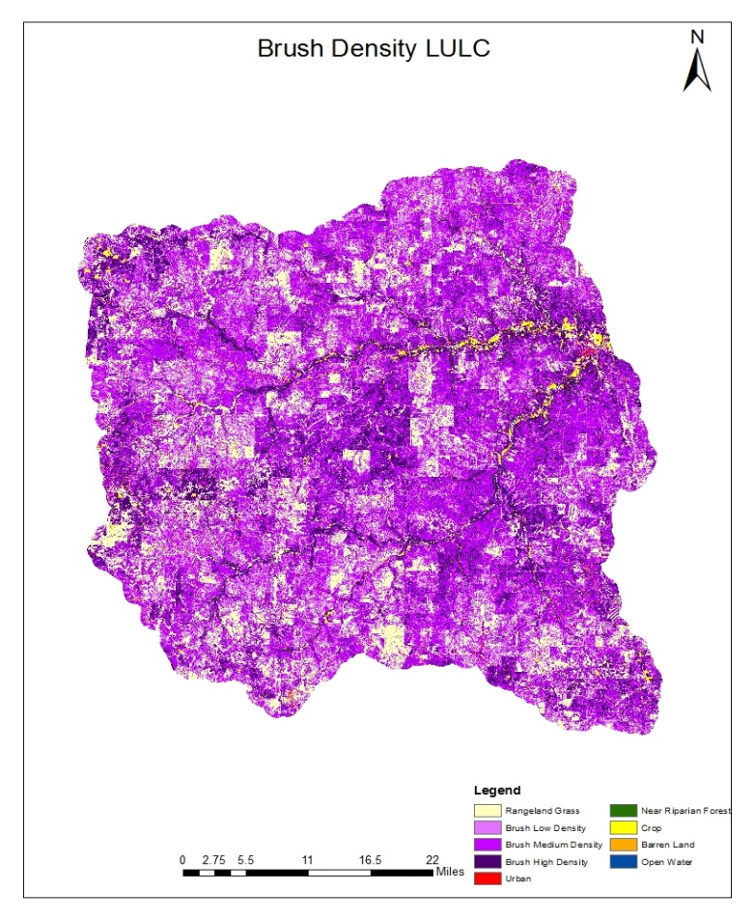
Map 2

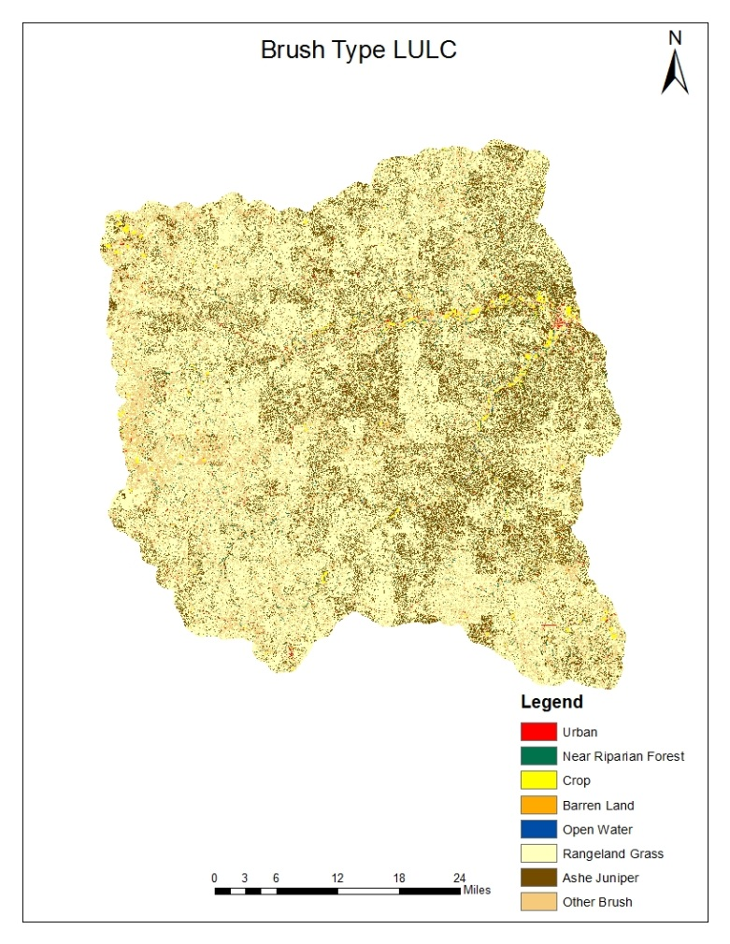
Map 3

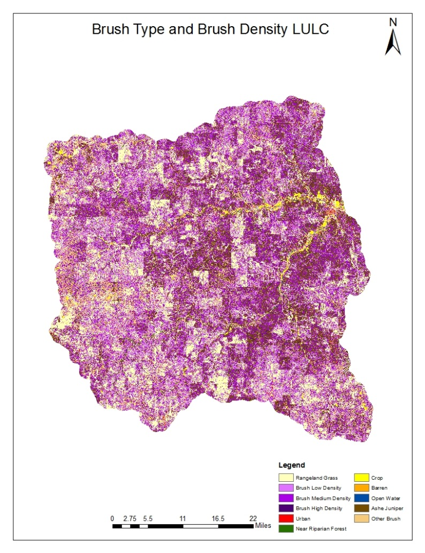
Map 4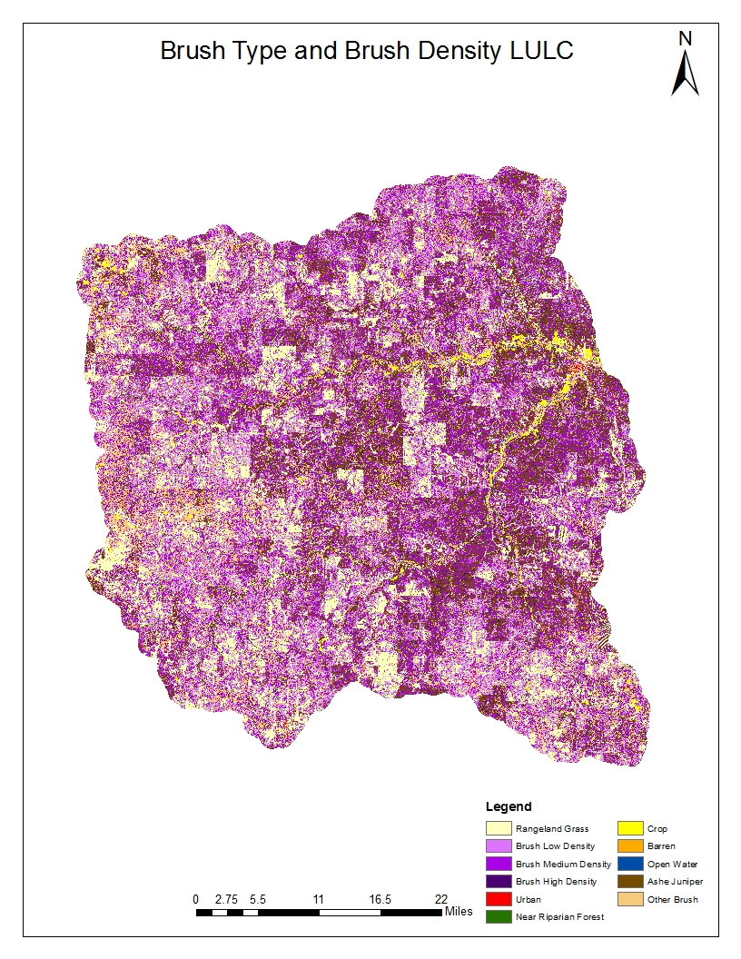

The classification of the ULRW proved to be very accurate. The use of NAIP 2010 images in conjunction with ancillary data assisted with making the classification more accurate. Because of the NLCD 2001, CDL 2010, Stratmap, and NHD, more classes could be added to the LULC map. Brush density was classified very well, but collecting more ground control points in conjunction with aerial photos would have helped produce a better accuracy assessment. Overall, the LULC maps determined the vegetation types and densities for the ULRW very accurately.

